JMP instruction of data visualization
Open distribution
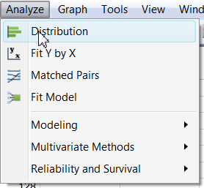
Drag the variable into Y, Column and click OK.
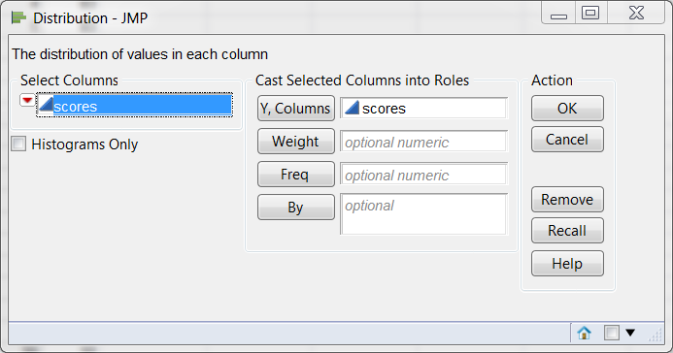
Change the appearance of the histogram by altering the bin width
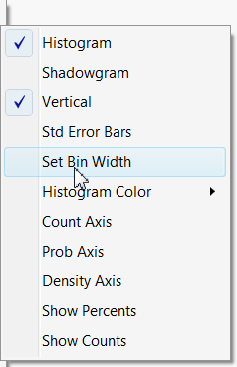
The following shows a histogram with a bandwidth of 5. The boxplot shows that there is an outlier. The quantiles correspond to the boxplot:
Percentile | Boxplot | Quantile | Scores | interpretation
75% | The upper edge of the box | 3rd quartile | 86 | If your score is 86, you are among the top 25%. You are doing better than 75% of other examinees.
50% | Middle bar | Median | 68.5 | Your ranking is right in the middle.
25% | The lower edge of the box | 1st quartile | 52.75 | Your performance is below about 75% of other examinees.

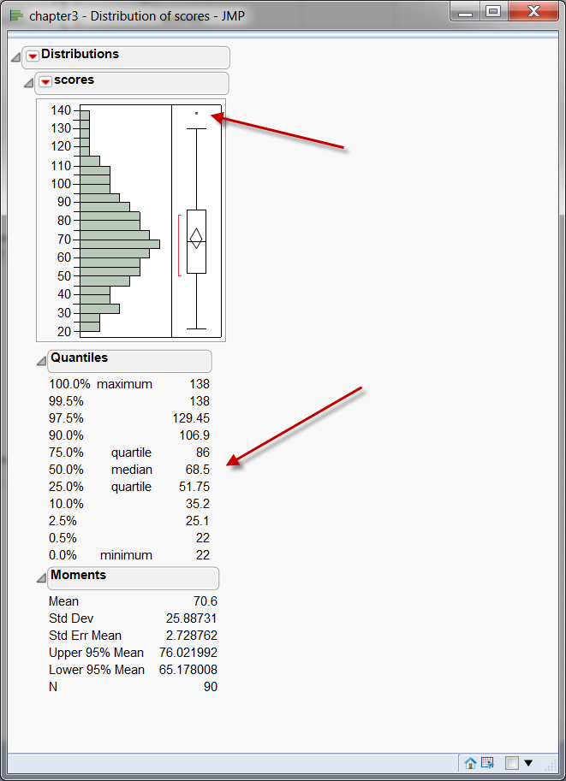
If you want to check whether the distribution is a substantive departure from normality, choose Normal Quantile Plot. The diagonal line is the ideal. The gaps between the observations and the line show the deviation from normality. In this picture all observations are close to the line and nothing is alarming.
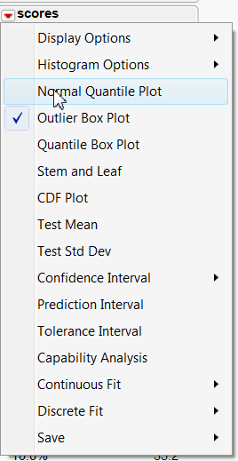

You can choose stem and leaf. But this graph does not show you additional information that you cannot find in the histogram.
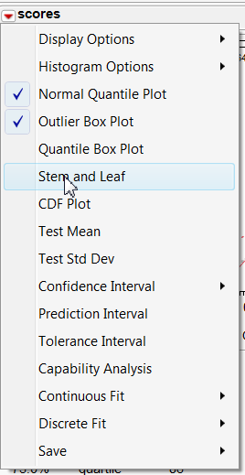

SPSS instruction
Select Frequencies from Descriptive Statistics
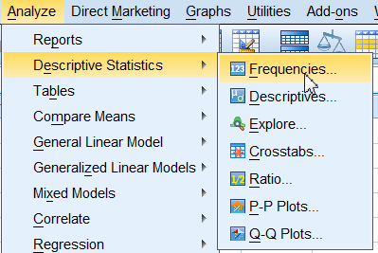
Select the variable and then click on Statistics, Next, you can define the percentiles by entering the number.
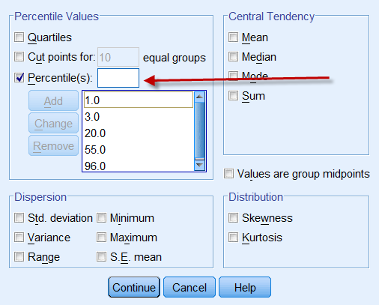
  Statistics
  scores
  N | Valid | 90
  N | Missing | 0
  Percentiles | 1 | 22.00
  Percentiles | 3 | 26.92
  Percentiles | 20 | 48.20
  Percentiles | 25 | 51.75
  Percentiles | 50 | 68.50
  Percentiles | 55 | 72.05
  Percentiles | 75 | 86.00
  Percentiles | 96 | 124.16

You can also get the boxplot and the stem and leaf plot from SPSS by choosing Explore from Descriptive Statistics. Open plots and then check Stem-andLeaf and Histogram
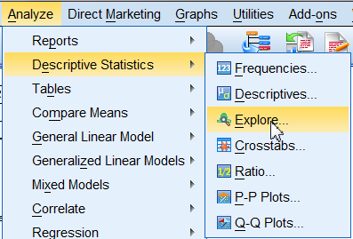 | 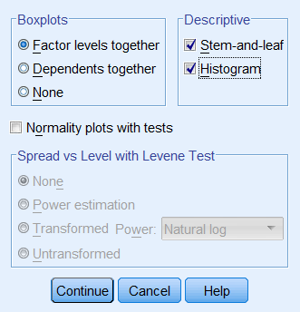

scores Stem-and-Leaf Plot  Frequency Stem & Leaf  11.00 0 . 22223333333  20.00 0 . 44444444555555555555  28.00 0 . 6666666666666667777777777777  18.00 0 . 888888888889999999  9.00 1 . 000000111  3.00 1 . 223  1.00 Extremes (>=138)  Stem width: 100  Each leaf: 1 case(s) | 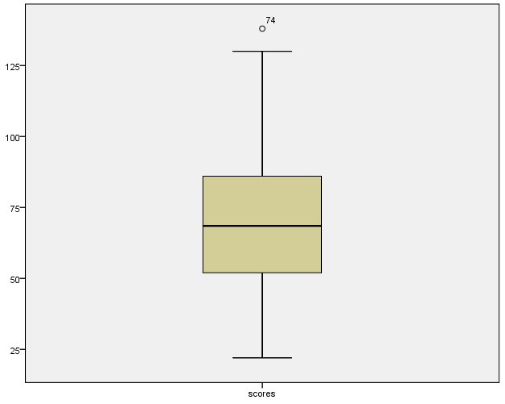

To change the bin width or the interval of the histogram, double-click the histogram to open Chart Editor. Next, double click the bar to open the properties.

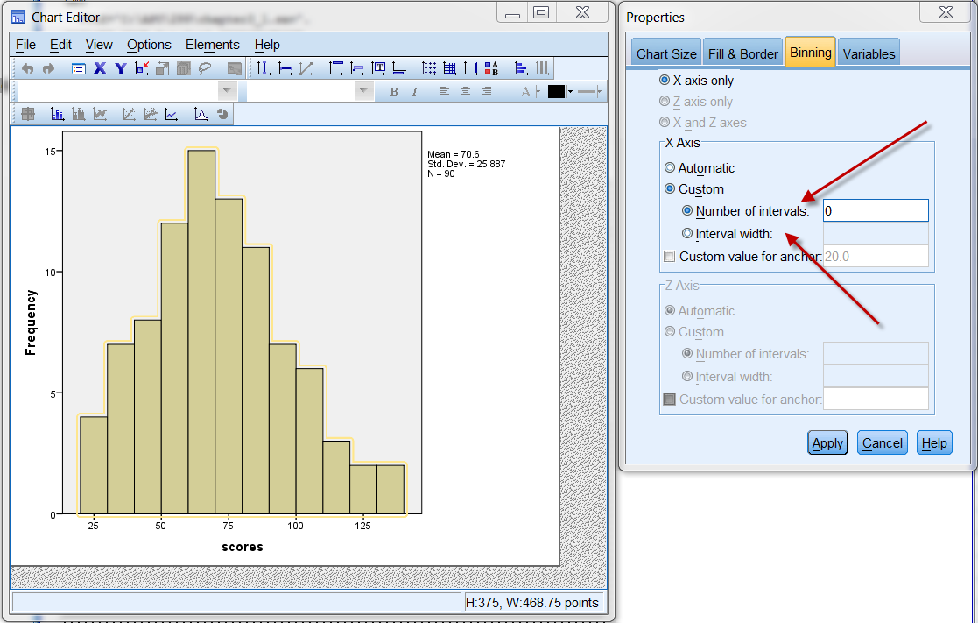

Excel instruction
Select the table and then select Line from Insert. Choose the second one at the left hand side. The bar chart and the line chat show the same information. But obviously it is easier to see the trend using the line chart.
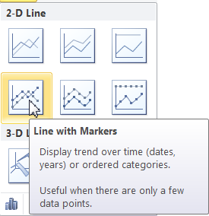
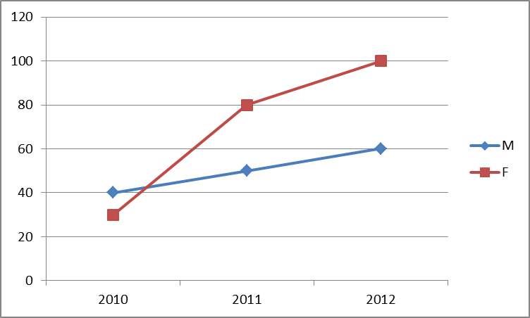 | 