Proper use of APA

Dear students,
If you do not have the APA manual at hand, you can find numerous websites showing examples of APA references and citations. The following is an example:

http://owl.english.purdue.edu/owl/resource/560/01/

In this write-up I would like to highlight four common mistakes: First, many students put down the names of the databases in the references. According to APA, "with the exception of hard-to-find books and other documents of limited circulation delivered by electronic databases, the database name is no longer a necessary element of the reference. This change is made in the interest of simplifying reference format. If you do include the database name in a reference, do not include the database URL” (the APA 2007 update).

Second, the issue number of the journal can be omitted when the page numbers are consecutive across all the issues in the same volume. Please read the following carefully:

Journal Numbered by Volume

These journals are paginated by volume. In each volume it begins with page one in Issue one, and then continue numbering in subsequent issues. For this type of journal you can omit the issue number.

Egerton, G. (2004). Entering the age of human rights: Religion, politics, and Canadian liberalism, 1945-50. Canadian Historical Review, 85, 451-479.

Journal Numbered by Issue

This refers to journals in which each issue begins with page number 1. After the volume number, put a period and then the issue number. Italicize the volume number, but not the issue number.

Messud, C. (2004). Then. Kenyon Review, 26(4), 34-45.
How can you tell whether the journal is paginated by volume or by issue. The rule of thumb is: If the page numbers are very huge (e.g. 499-510), then you know that it is impossible for a single issue to carry 500 pages. It must be paginated by volume.

Third, many students use excessive direct quotations when it is unnecessary. Indeed, it is more efficient to simply rephrase the ideas of an article. Nonetheless, sometime a direct quotation is needed. For example,

- The original statement is very profound (e.g., “Ask not what this country can do for you. Ask what you can do for this country.”)
- The original statement is so complicated that its meaning may be distorted after paraphrasing (e.g. “Uncritical semantics is the myth of a museum in which the exhibits are meanings and the words are labels. To switch languages is to change the labels.”)
- You want to analyze the original statement word by word.

Last, many students assume that whatever is found on a library website, it must be correct. Today many academic databases provide users with a citation tool, as shown in the following:

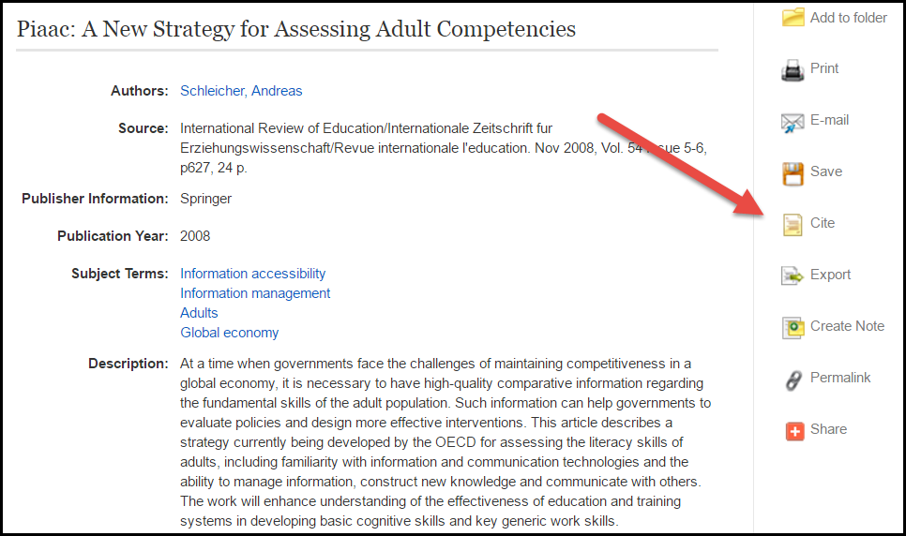

It is tempting to use this feature as a short cut. Please read the fine print: Review the instructions at EBSCO Support Site and make any necessary corrections before using. Pay special attention to personal names, capitalization, and dates. Always consult your library resources for the exact formatting and punctuation guidelines.

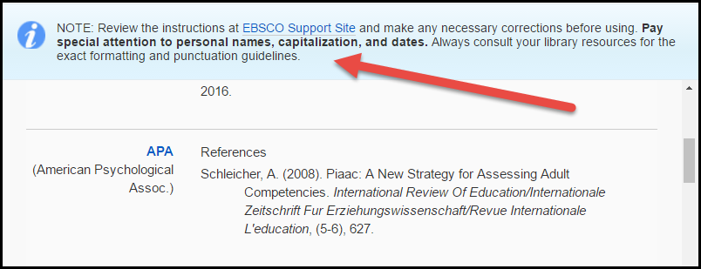

However, some students do not read the note. As a matter of fact the library references are formatted by an automated system, and unfortunately the computer is blind to errors. Can you see something wrong in the following reference?

Schleicher, A. (2008). Piaac: A New Strategy for Assessing Adult Competencies. International Review Of Education/Internationale Zeitschrift Fur Erziehungswissenschaft/Revue Internationale L'education, (5-6), 627.

There are at least six mistakes:

- PIAAC is an acryom and therefore “Piaac” should be written as “PIAAC”
- There is no need to capitalize the first letter of each word for the article title.
- There is no need to capitalize the first letter of a preposition (e.g. of, for, in…etc.)
- When citing a foreign journal, you need to transliterate or translate the article title into English, but not the journal title.
- If the page numbers are consecutive across all the issues in the same volume, you need to include the volume number only, but not the issue number.
- You need to include the first and the last pages of the article.

Hence, the correct format should be as follows:

Schleicher, A. (2008). PIAAC: A new strategy for assessing adult competencies. International Review of Education/Internationale,54 ,627-650.

